Chapter 16, Solution 5.

The responses of a series RLC circuit are

v_{C}(t) = [30 – 10e^{–20t} + 30e^{–10t}]u(t) V

i_{L}(t) = [40e^{–20t} – 60e^{–10t}]u(t) mA

where v_{C}(t) and i_{L}(t) are the capacitor voltage and inductor current, respectively. Determine the values of R, L, and C.

Solution

Step 1. We can start with the generalized mesh equation for a series RLC network. We can lump the initial conditions (v_{C}(0) = 30–10+30 = 50 volts and i_{L}(0) = 40–60 = 20 amps) with the source in the loop since all we are currently after are the values of R, L, and C.

RI(s) + Ls(I(s)+20/s) + (1/C)I(s)/s – 50/s – V(s) = 0 or [s² + (R/L)s + 1/(LC)]I(s) = (V(s)/L) – 20 + 50/(Ls)

Step 2. The values of R, L, and C will come from the roots of the denominator s equation. We already know that they are equal to –10 and –20. We note however, that this will give us only two equations. Obviously we need a third, and that will come from knowing the current through the capacitor and the voltage across it.

s_{1,2} = 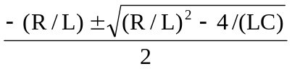 = –10, –20
We can simplify our effort by noting that s₁ + s₂ = –R/L[(1/2)+(1/2)] = –30 or R = 30L.
Next, s₁ – s₂ = 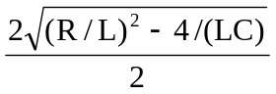 = 10 or (R/L)² – 4/(LC) = 100. Since (R/L) = 30, we then get 900 – 100 = 4/(LC) or LC = 4/800 = 1/200.

Now we work with i_{C}(t) = Cdv_{C}(t)/dt or 40e^{–20t} – 60e^{–10t} mA =
C[200e^{–20t} – 300e^{–10t}] V or C = 0.2x10^{–3} = 200 µF. Since LC = 1/200 then L = 1/(200x200x10^{–6}) = 1/0.04 = 25 H. Finally R = 30L = 30x25 = 750 Ω.

750 Ω, 25 H, 200 µF

